GRAPHILATOR

Submitted By: | Nilan Varghese Mathew
Registration Number: | 26BMR10024
Course: | CSE1021-Introduction to Problem Solving and Programming
Faculty: | Mr. Sivabalan K. R

BONAFIDE CERTIFICATE
This is to certify that the project report entitled "Graphilator" is a Bonafide record of work done by Mr. Nilan Varghese Mathew bearing Registration Number 26BMR10024, in partial fulfillment of the requirements for the course CSE-1021 Introduction to Problem Solving and Programming during the academic year 2026-2027.
I carried out this project work under my direct supervision and guidance. And in no way plagiarized in any form or manner.

Nilan Varghese Mathew
Registration No:26BMR10024
Student Signature: ________
Mr. Sivabalan KR
Teacher’s Signature:________

Table Of Contents:
- Introduction
- Modules expected in the programme
- Explanation of each programme
- Flowcharts Of the Modules
- Input/Output of the Modules
- Conclusion of the report

Introduction
Mathematics plays an integral part in our lives, and so do the sub-branches in the field of mathematics. From the stock market to government agencies, we use calculus and statistics. This project is an honest attempt to unify the core ideas of mathematics into one simple program that the user can access using the ever-powerful yet understandable language of Python. I believe that the further development of this program will cause a boom in people taking mathematics and thus make a better world for all of us. The developer tries to make the calculus part and the graphical part of mathematics into one beautiful symphony that is as comparable to the musical genius of Beethoven or Mozart.
Modules
This menu-driven program consists of 5 Python files: cll_interface, plotter, stats, calculus, and test_calculus. They are individually programmed to work on one interface, cll_interface, where the user can check the derivatives and integrals, plot the function and its integrals and derivatives, and plot histograms and parabolas, and curves.
Module 1:cll-interface
  - The flowchart for the file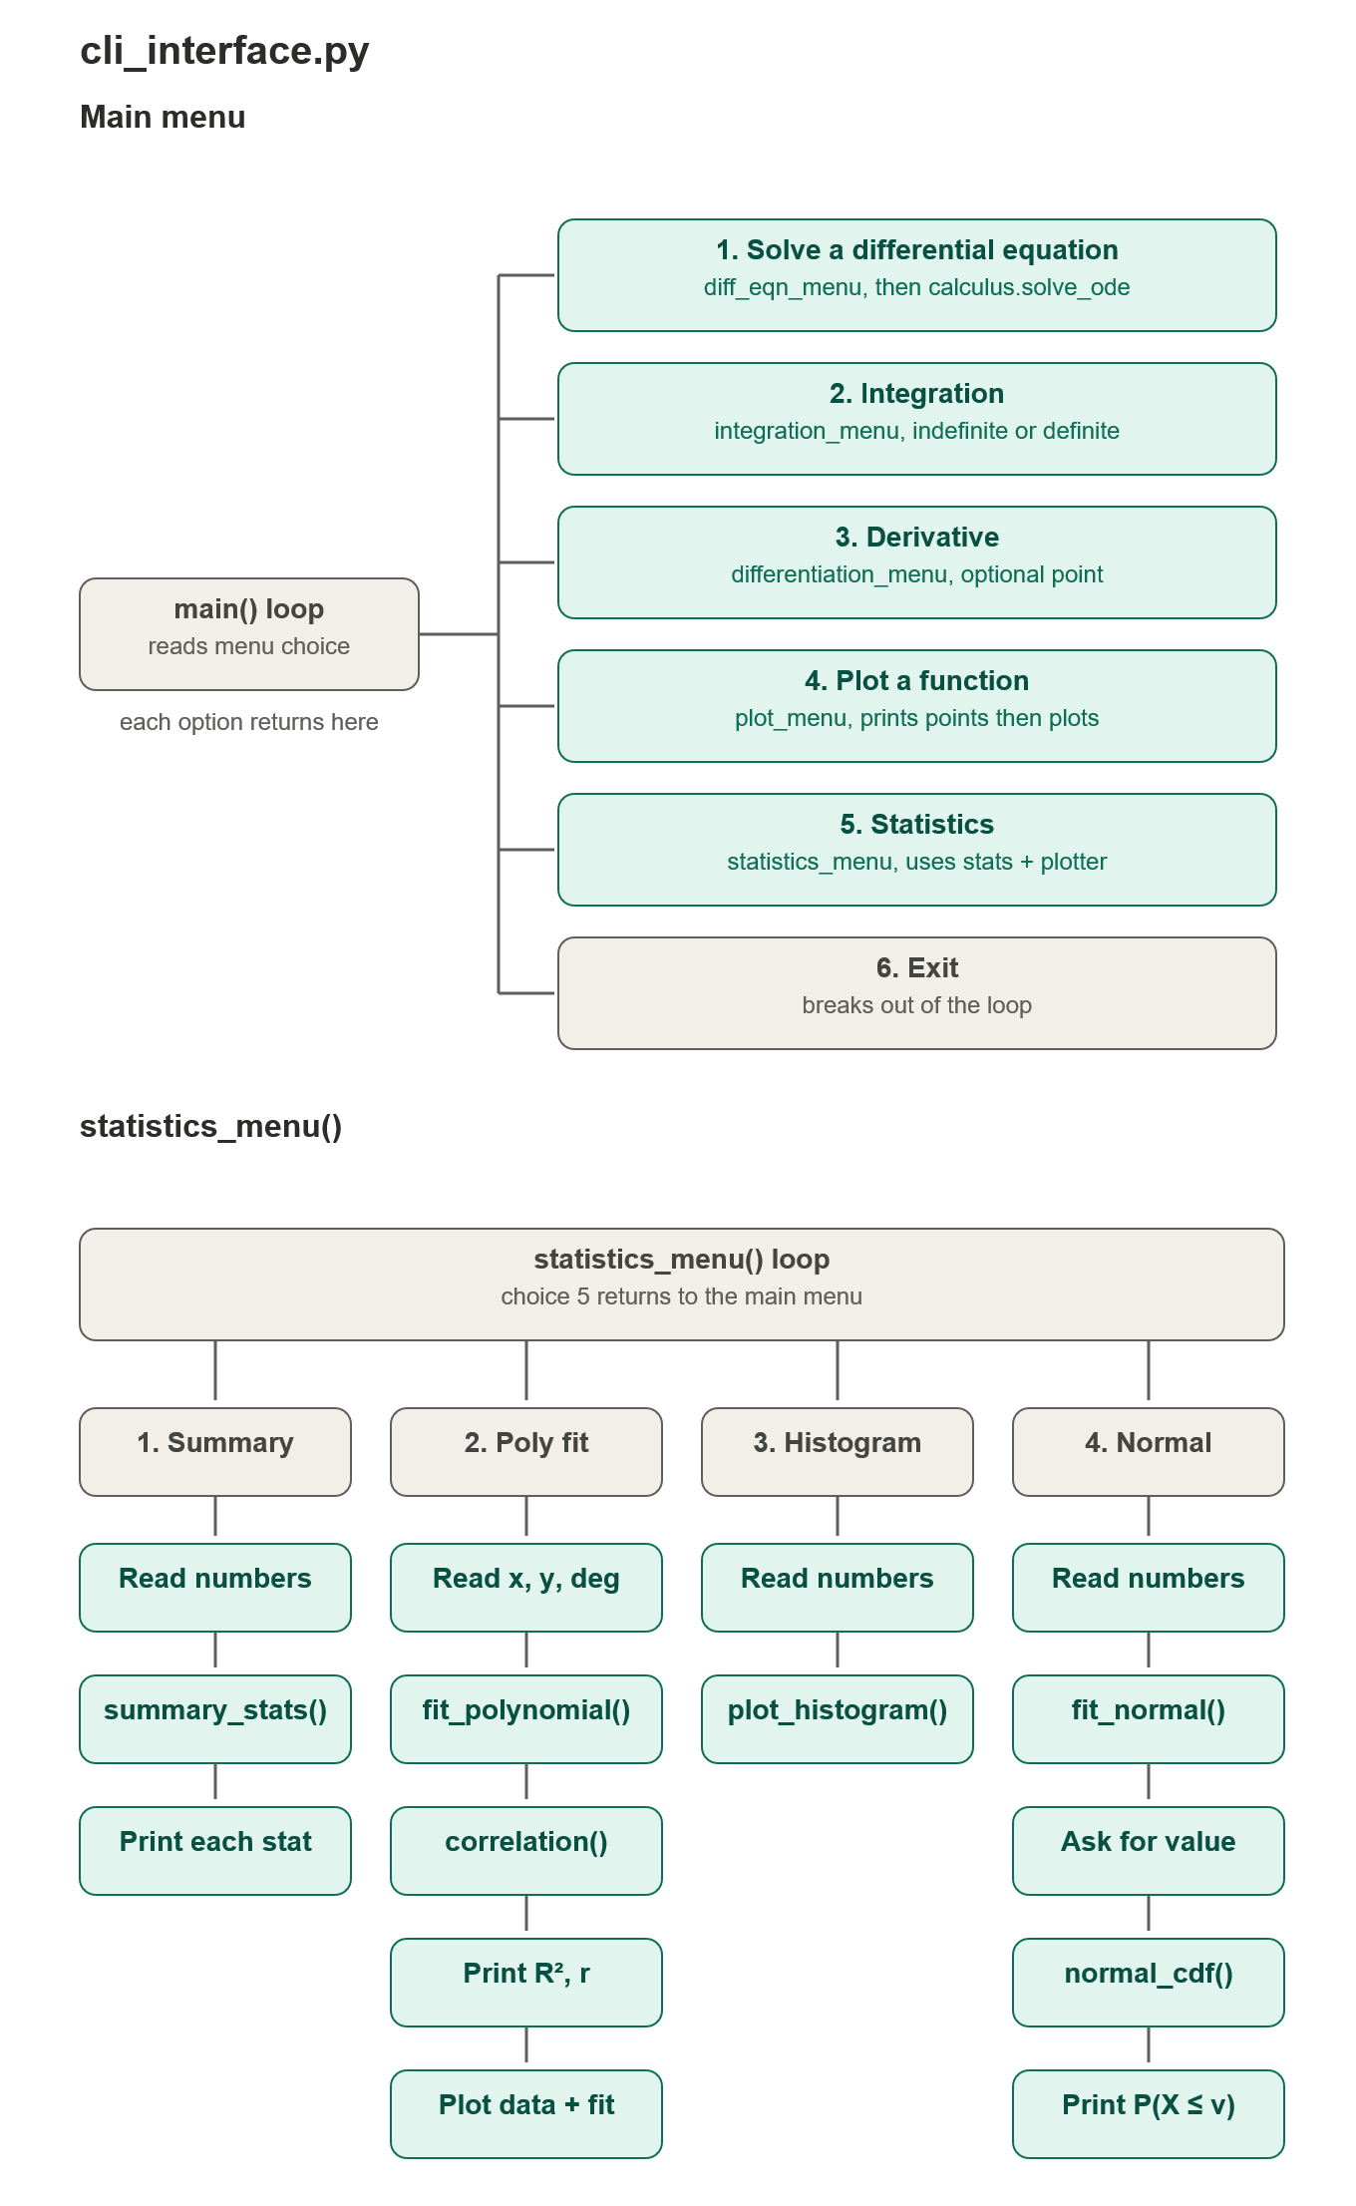
  - Purpose of the module
This module is the main area where the user would execute the different functions that he would like to use like the home screen of a smartphone or of an app
  - What the module does
This module is the communication point between the user and the backend data stored in the other files
  - Input
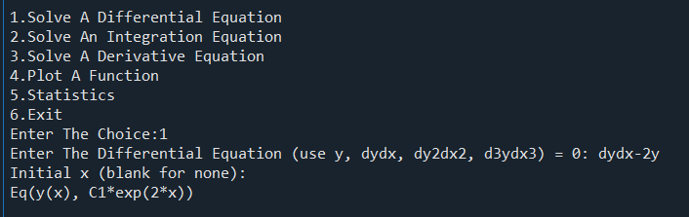
Fig 1

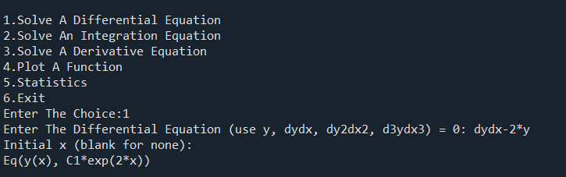
Fig 2
In this figure, the user inputs a variable-separable differential equation and gets the output. The user can type normally, as if they were writing it in their notebook, or type it in a programming way and get the same answer. This equation is passed onto the calculus module, which processes it to the differential equation function, and it returns the output to the cll_menu, which shows us the current output.

  - Error Handling
- Non-numeric text in int() prompts crashes the program before _safe() runs.
- Trailing commas or blanks in _floats() trigger an unhandled ValueError.
- Unequal lengths for X and Y coordinate lists will crash curve fitting.
- Leaving y(x0) empty passes blank values into ODE initial conditions.
- Undefined mathematical domains (like dividing by zero) break plotting and integration.
- Typing an invalid menu number silently fails without a warning message.
  - Technologies Used
Python 3: The core programming language running the CLI and mathematical backend.
SymPy: Library used behind the scenes for symbolic math, algebraic parsing, differentiation, and symbolic ODE solving.
NumPy: Used for array handling, numerical evaluations, and polynomial fitting.
SciPy: Used for statistical probability distributions (scipy.stats) and numerical solvers.
Matplotlib: Library used by plotter to render coordinate plots, curves, and histograms.
Module 2:calculus.py
  - Flowchart of the module
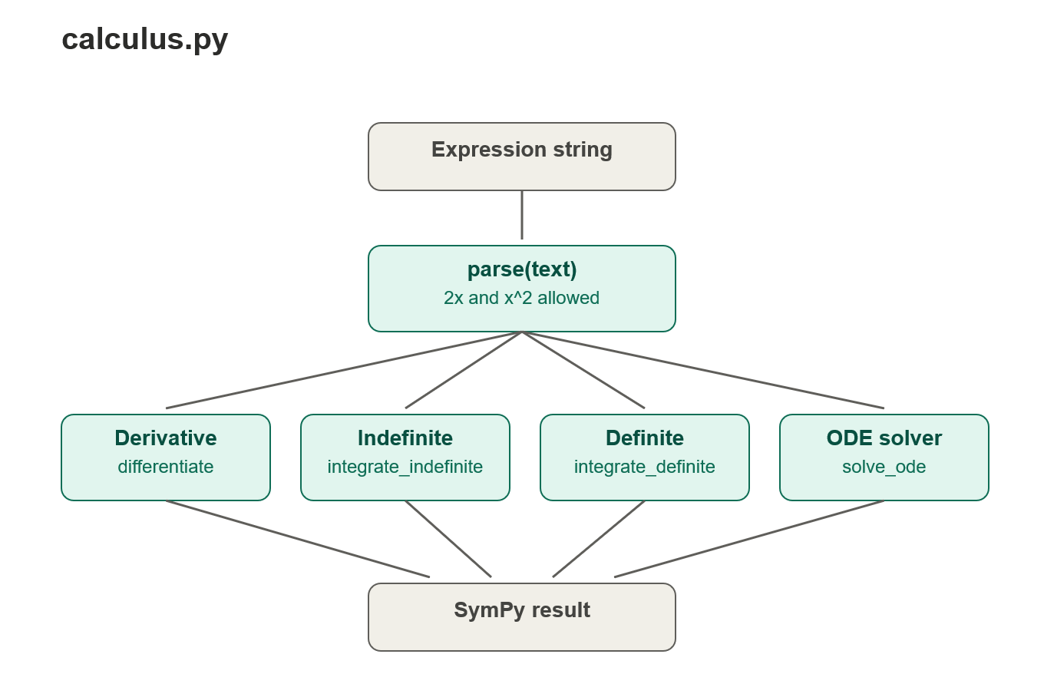
  - Purpose of the module
This module is used for storing and calling the functions for integration, differentiation and differential equations
  - What the Module is for
This module serves as the bridge between the calculator and integration, differential equations, and differentiation.
  - Input
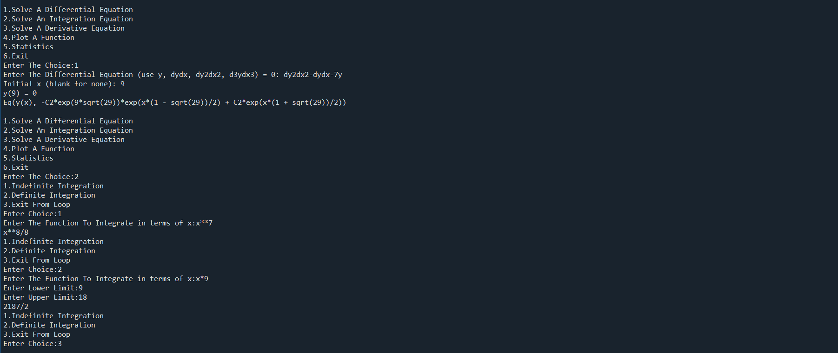
The user inputs the choice from the three different choices given by the menu. The user inputs the choices, and the cll_menu calls the appropriate function
1.diff_eqn_menu = for solving differential equations
2.integration_menu = for solving the definite and indefinite integrals
3.differentiation_menu = for solving the definite and indefinite derivatives upto the n^{th} order
The function processes the choice and returns the output using the arguments and parameters given by the user
  - Error Handling
1.There is no try block when the user types an invalid expression
2. Input such as sinx causes an error in the program
3. Negative differentials will raise an error in the program

Module 3: stats.py
# Named to avoid a clash with statistics, which is a module in Python#
3.1 The Flowchart of the module
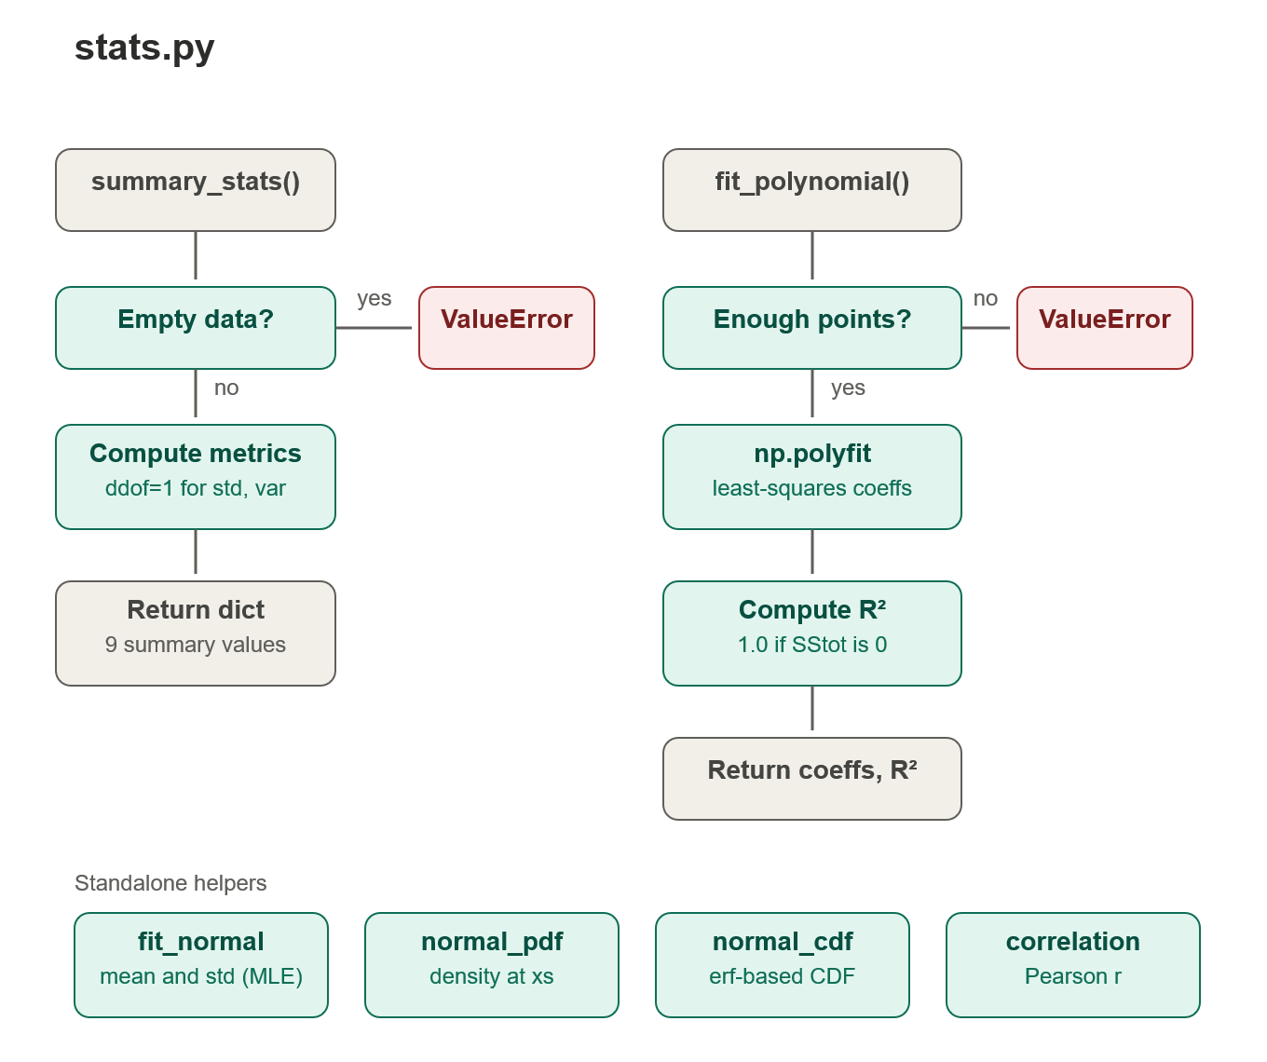

3.2 Purpose Of The Module
Does the statistics required by the user and gives the output
3.3 What the module does
This module serves as a gap between the statistical function and the calculator menu
3.4 Input
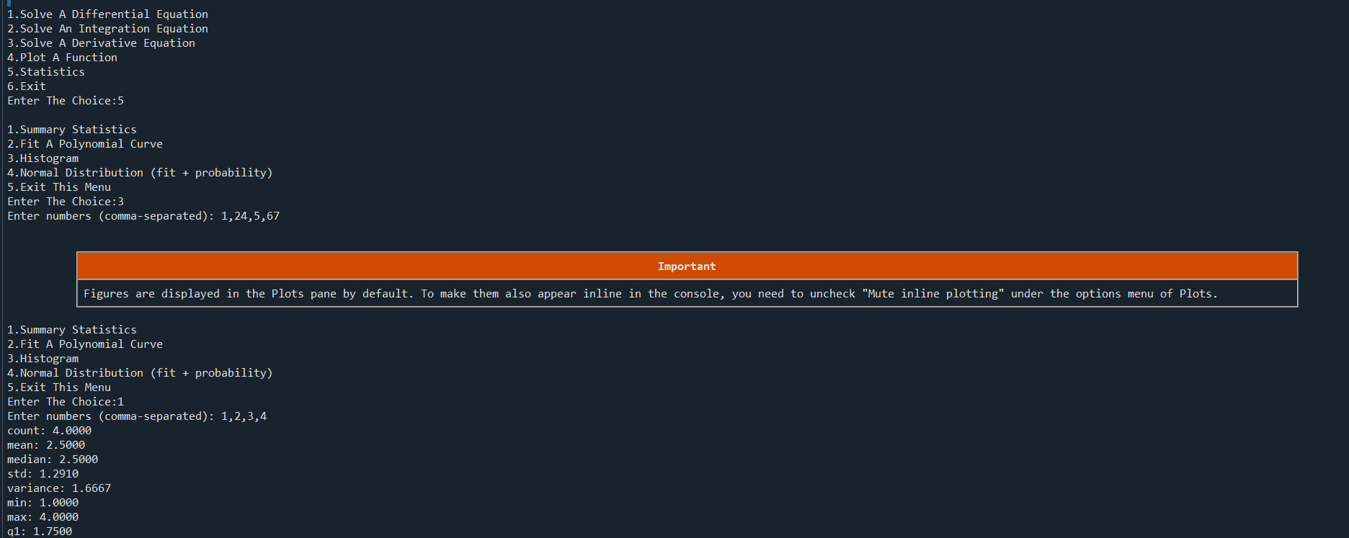
The user inputs the choice for the stats module where they can access the variance minima, maxima, and average of the function we also have graphs such as a histogram, which gets values and prints out a histogram.
3.5 Error Handling
Zero standard deviation: Identical values set sigma = 0, causing a ZeroDivisionError in PDF and CDF functions.
Empty inputs in fit_normal: Passing an empty list produces runtime warnings and returns NaN values.
Identical coordinates in correlation: Constant $X$ or $Y$ values cause np.corrcoef to return NaN.
Negative polynomial degrees: Passing a negative degree breaks NumPy's internal fitting function.
3.6 Programmer Use
1. Python 3: Base programming language.
2. NumPy: Used for vector arrays, statistical calculations, and polynomial curve fitting (polyfit, polyval, corrcoef).
3. Math Module: Standard library used for scalar math operations (sqrt, pi, erf).
Module 4: Plotter.py
4.1 Flowchart for the module
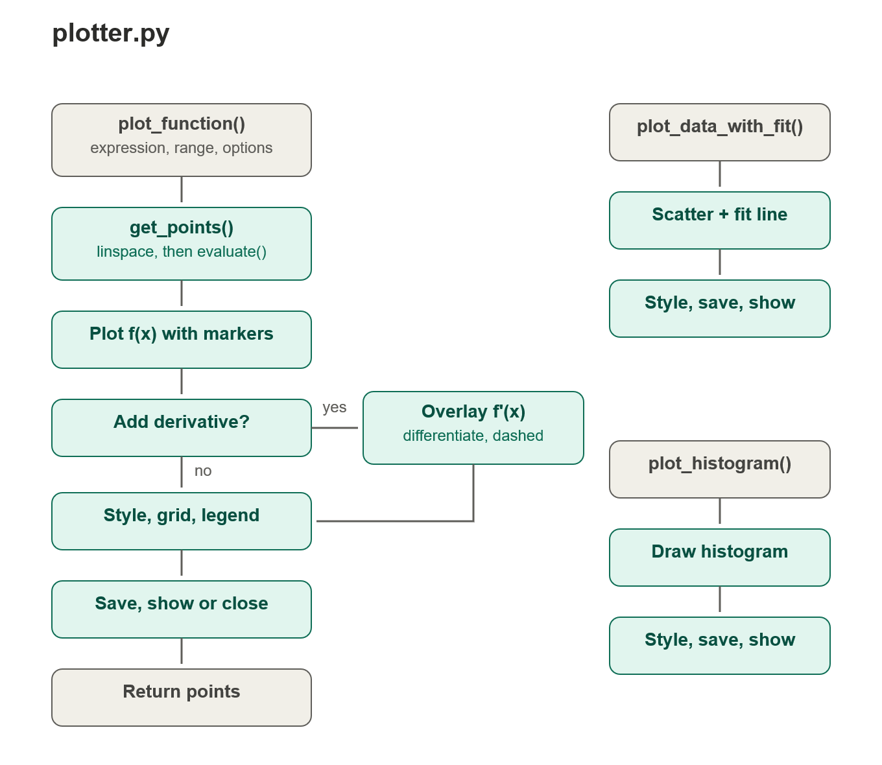

4.2 What this Module Does
This function plots the graph with values input by the user and gives out the output using the Spyder plot tab located in the top right
4.3 Inputs
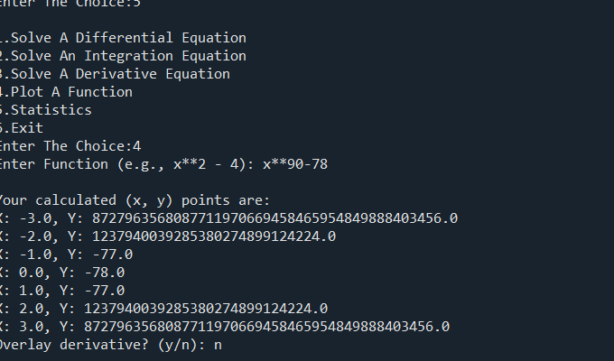
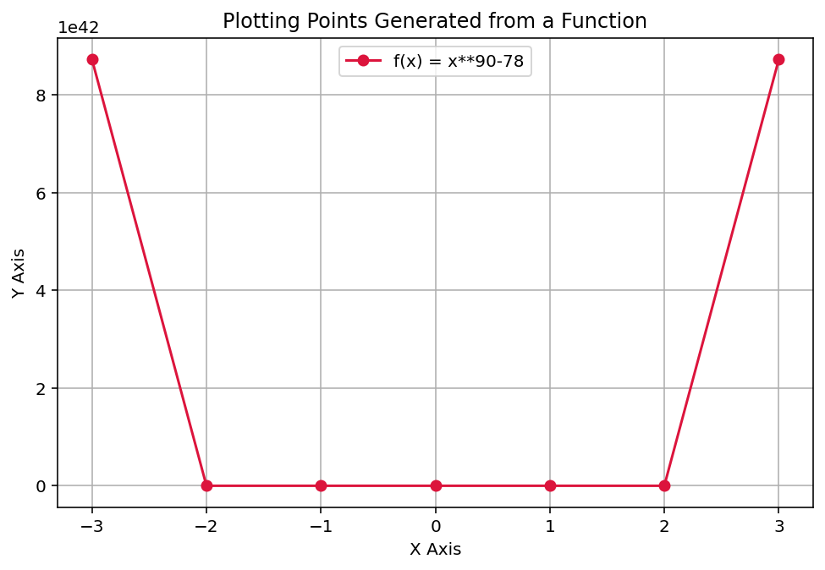

The user inputs the function x⁹⁰ – 78 and the function plot processes and gets the values from -3,3 and the function plots the graph above
4.5 Error Handling
1. Plotting expressions with division by zero (like 1/x) produces inf warnings and distorted lines.
2. Functions evaluated outside their domain (like sqrt(-1) or log(-1)) throw runtime warnings or complex number errors.
3. Syntax errors or broken formulas trigger unhandled parsing exceptions inside calculus.parse().
4.Passing empty lists into histograms or scatter plots crashes the script with a ValueError.
5. Identical X coordinates collapse np.linspace(xs.min(), xs.max()) down to a zero-width range.
6. Supplying an invalid directory path for save_path raises an unhandled FileNotFoundError
4.6 Technologies Used
1. Python 3: Primary language running the plotting module.
2. Matplotlib (matplotlib.pyplot): Generates line plots, scatter charts, and histograms.
3.NumPy (NumPy): Handles array generation with linspace, grid points, and polynomial evaluation via polyval.
4.SymPy (sympy): Compiles symbolic math expressions into fast numerical functions using sp. lambdify.
5.calculus.py: Internal module used to parse strings and calculate derivatives for plotting overlays.

Module 5: test_calculus.py
5.1 Flowchart Of The Code
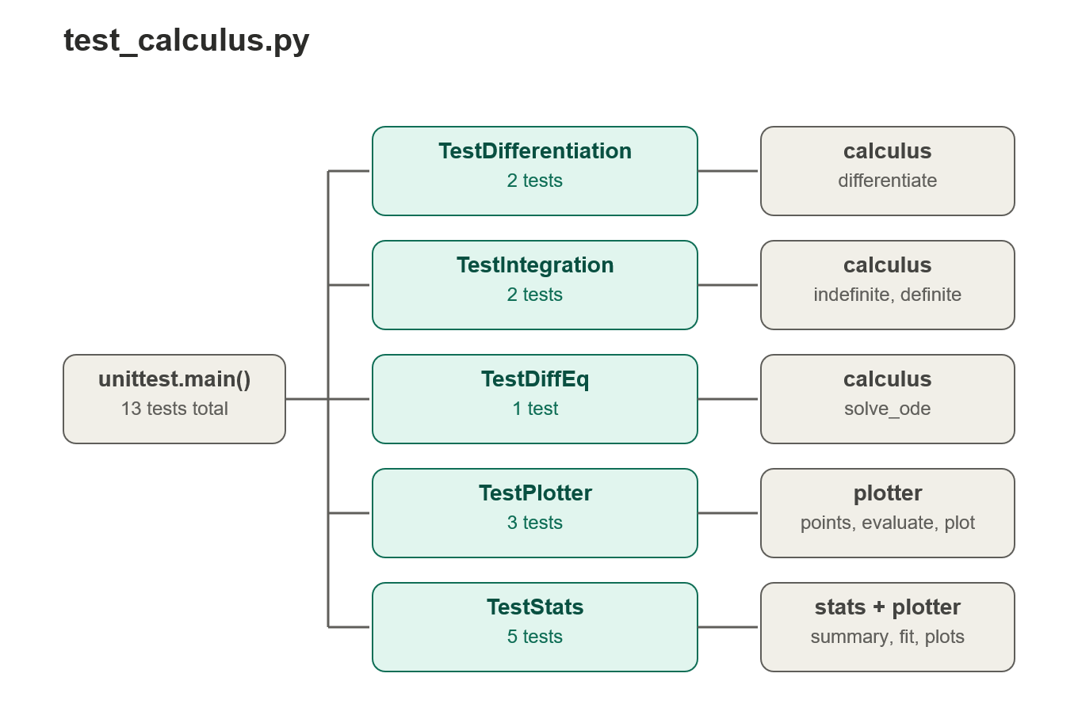
5.2 What the Module Does
The Module Tests the functionality of the above calculus.py using the command line and communicates using the cll_menu.py
5.3 Inputs
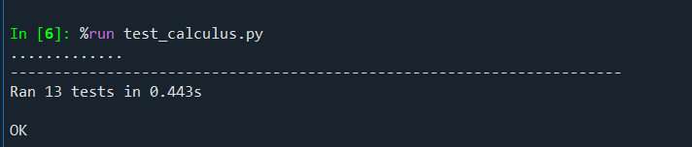
This test is used to check for any defects in the calculus functions the user may run this on the cll_menu.py using

5.4 Process
•1.Automated test cases subclassing unittest.TestCase run calculations across differentiation, integration, ODEs, plotting, and statistics.
2. Backend outputs are passed into assertion checks like assertEqual to verify them against exact analytical solutions.
3. Tests execute headlessly without user intervention, terminating with an atomated pass/fail report.
5.5 Technologies Used
1.unittest: Python's built-in testing framework used to structure, group, and execute test cases.
2. SymPy & NumPy: Used to perform symbolic comparisons with sp.simplify() and supply numerical array coordinates.
3.Matplotlib: Configured via matplotlib.use("Agg") to handle chart generation entirely in system memory.
5.6 Error Handling
1. self.assertRaises(ValueError): Verifies that functions like stats.summary_stats([]) raise expected exceptions on invalid inputs.
2.assertAlmostEqual(): Handles floating-point rounding discrepancies to prevent false assertion failures.
3.Headless Display Guard: Disables GUI windows using the "Agg" backend and show=False so test runs do not hang.

Conclusion
This project, with the right amount of future updates, can be used as a tool for future calculus students to enjoy calculus in an interactive way

